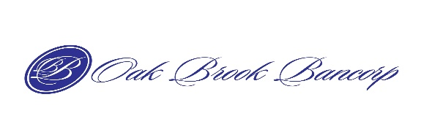

NEW CUSTOMER ACCOUNT INFORMATION

First Name: ____________________ Last Name: _____________________________ Date: ______________
Home Address: ______________________________________________________________________________
City: _________________________ State: __________ Zip: ______________________
Cell#: ________________________ Email Address: ______________________________________
Years Licensed: □ under 1yr □ 1-3yrs □ 4-6yrs □ 7-10yrs □10 +yrs
CURRENT # OF EXCLUSIVE TENANT REPRESENTATIVE AGREEMENTS? __________
# OF SIGNED EXCLUSIVE TENANT REPRESENTATIVE AGREEMENTS IN THE LAST 12 MONTHS? _____________
MY BUSINESS IS OPERATED AS A: □ Sole Proprietor □ LLC □ Corporation
CURRENTLY IN BANKRUPTCY? □ Yes □ No

COMPANY INFORMATION:
Company Name: ___________________________________________________________________________
Company Street Address: ____________________________________________________________________
City: _________________________ State: __________ Zip: _____________________
Company Phone: __________________________________
Managing Broker Name: ___________________________________
Managing Broker Email: ___________________________________

All information provided will be kept confidential and will not be sold or distributed.
PLEASE COMPLETE AND EMAIL TO: loanrequest@oakbrookbancorp.com
YOU MUST ALSO SUBMIT A LOAN REQUEST TO COMPLETE THIS PROCESS. RETURN TO THE CONTACT PAGE AND CLICK ON LOAN REQUEST LINK.

